A nondeterministic Turing machine M with start state q₀ and accepting state q_{f} has the following transition function:
δ(q, a) | 0 | 1 | B
q₀ | { (q₁, 0, R) } | { (q₁, 0, R) } | { (q₁, 0, R) }
q₁ | { (q₁, 1, R), (q₂, 0, L) } | { (q₁, 1, R), (q₂, 1, L) } | { (q₁, 1, R), (q₂, B, L) }
q₂ | { (q_{f}, 0, R) } | { (q₂, 1, L) } | { }
q_{f} | { } | { } | { }
Simulate all sequences of 5 moves, starting from initial ID q₀1010. Find what ID's are reachable from the initial ID in EXACTLY 5 moves.
TURING MACHINE DIAGRAM:
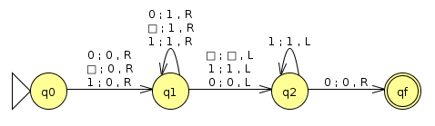Turing machine

SIMULATION RESULT (5 MOVES) FOR STRING 1010:
 | ① |  | ② |  | ③ |  | ④ |  | ⑤
 |  |  |  |  | ⊢ | 011q₁0 | ⊢ | 0111q₁ | ⊢ | 01111q₁
 |  |  | ⊢ | 01q₁10 |  |  |  |  | ⊢ | 011q₂1
q₀1010 | ⊢ | 0q₁010 |  |  |  |  | ⊢ | 01q₂10 | ⊢ | 0q₂110
 |  |  |  |  | ⊢ | 0q₂110 | ⊢ | q₂0110 | ⊢ | 0q_{f}110
q₀1010 | ⊢ | 0q₁010 | ⊢ | q₂0010 | ⊢ | 0q_{f}010

